How to create a repository:

Git work flow:

1. First create a repository
2. put some files into that repository
3. Add those files
4. commit those files
5. Push those files to central repository

Open Github account with username and password

In Create a new repository give some name class1

Click on create Repository.

If we have any old repositories then to clone, click on import code

Now in command line,

To initialize a git repository: Give command: git init

create a file using command : touch file1

here file1 is the name of a new file that we are creating.

Edit this file using command: vi file1

To insert some message (to write some thing init) , press escape i

Now its ready to give some message as hello

Now press escape :wq!

Means write and quit.

Now press enter, this file1 is saved

To check whether the message is saved in file1, use command : cat file1

Then it shows the message

Now we need to add this file1 to git using command : gitadd file1

Or git add *

Now to see the status use the command: git status

Now we can see the files which are there in that file

At first or now, we have to configure user name and user email as

Command: git config –global user.name sree

Git config –global [user.emailsatishluck.chinnu@gmail.com](mailto:user.emailsatishluck.chinnu@gmail.com)

Now use command to commit

Git commit –m “hello”

Now, if we give command: git status

Then we get as on branch master, nothing to commit, working tree clean

Open github window and copy this command



Paste it in linux

And copy the next



Paste it in linux

(Yes/no) type yes

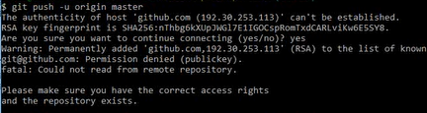

Permission denied (publickey) because ssh key is not done

To do this command: ssh-keygen

This command will setuo a sshkey,

It will ask for username, password – don’t give anything – just press enter

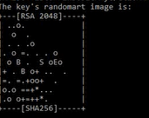

Will be created.

Now in normal laptop, click on c drive --- user—satis-- .ssh---id_rsa.pub

Open id_rsa.pub right click on edit with notepad++

Copy that whatever in it.

Go to github window go to icon on right top—go to settings

Click on SSH and GPG keys

Click on new ssh key